# SQL QUERY DOCUMENT

1. SELECT COUNT(*) AS Total_rows FROM Walmart_sales;

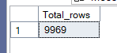

1. SELECT DISTINCT payment_method FROM Walmart_sales;

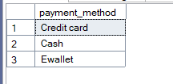

1. SELECT DISTINCT payment_method,COUNT(*) FROM Walmart_sales GROUP BY payment_method;

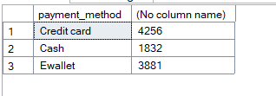

1. SELECT COUNT(DISTINCT Branch) AS Unique_Branches FROM Walmart_sales;



1. SELECT MIN(quantity) as Minimum_quanity FROM Walmart_sales;

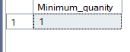

## WALMART BUSINESS PROBLEMS

1. What are the different payment methods, and how many transactions and items were sold with each method?

SELECT payment_method,COUNT(*) AS no_transactions, SUM(quantity) AS items_sold FROM Walmart_sales GROUP BY payment_method;

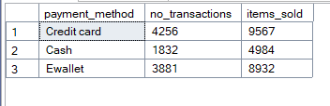

1. Which category received the highest average rating in each branch?

SELECT Branch, category, avg_rating

FROM (

SELECT

Branch,

category,

AVG(rating) AS avg_rating,

RANK() OVER(PARTITION BY branch ORDER BY AVG(rating) DESC) AS rank

FROM Walmart_sales

GROUP BY branch, category

) AS ranked

WHERE rank = 1;

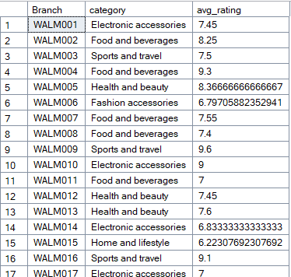

… 101 rows

1. Calculate the total quantity of items sold per payment method

SELECT

payment_method,

SUM(quantity) AS no_qty_sold

FROM Walmart_sales

GROUP BY payment_method;

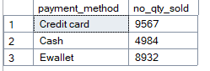

1. Determine the average, minimum, and maximum rating of categories for each city

SELECT

city,

category,

MIN(rating) AS min_rating,

MAX(rating) AS max_rating,

AVG(rating) AS avg_rating

FROM Walmart_sales

GROUP BY city, category;

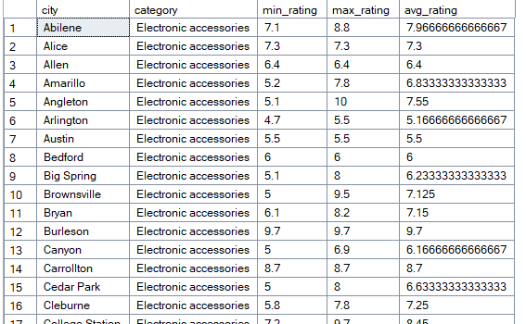

…..rows

1. Calculate the total profit for each category

SELECT

category,

SUM(unit_price * quantity * profit_margin) AS total_profit

FROM Walmart_sales

GROUP BY category

ORDER BY total_profit DESC;

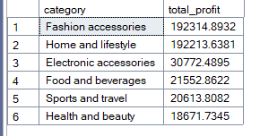

1. Determine the most common payment method for each branch

WITH cte AS (

SELECT

Branch,

payment_method,

COUNT(*) AS total_trans,

RANK() OVER(PARTITION BY Branch ORDER BY COUNT(*) DESC) AS rank

FROM Walmart_sales

GROUP BY Branch, payment_method

)

SELECT Branch, payment_method AS preferred_payment_method

FROM cte

WHERE rank = 1;

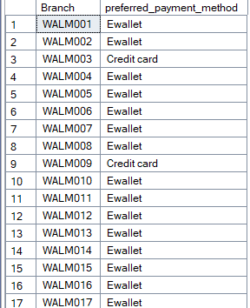

…rows